 | South Kyme Golf Club  Rabbits Section  Rabbit Section Committee | 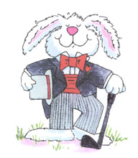

The committee is formed by 2 posts that are previously set and 5 posts that are voted on. The posts that are set are as follows: -

The Chairperson/Captain
The Vice-Chairperson/vice-Captain

The following posts are filled by nomination and voted on if there is more than 1 nominee for a post:-

Secretary
Treasurer
Member
Member
Member
The Current Committee

Ian Scholefield Chairperson/Captain
Andy Davis Vice-Chairperson/Vice-Captain
Helen Kirschner Secretary
Gary Noble Treasurer
Carole Fewings Member
Colin Bee Member
Andy Murton Member

Club Committee Reps

Management Committee Chairperson/Captain

Handicap and Competitions Gary Noble

Course Development Current Rabbits Captain

Bar & Catering Carole Fewings

Greens Committee Colin Bee

