 | South Kyme Golf Club  Rabbits Section  Rabbit Section Committee | 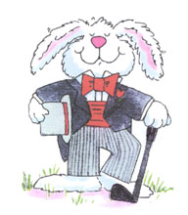

The committee is formed by 2 posts that are previously set and 5 posts that are voted on. The posts that are set are as follows: -

The Chairperson/Captain
The Vice-Chairperson/vice-Captain

The following posts are filled by nomination and voted on if there is more than 1 nominee for a post:-

Secretary
Treasurer
Member
Member
Member
The Current Committee

Andy Davis Chairperson/Captain
Dave Burrows Vice-Chairperson/Vice-Captain
Helen Kirschner Secretary
Gary Noble Treasurer
Carole Fewings Member
Mark Williamson Member
Eric Woods Member

Club Committee Reps

Management Committee Andy Davis

Handicap and Competitions Gary Noble

Course Development Current Rabbits Captain

Bar & Catering Carole Fewings/Helen Kirschner

Greens Committee Andy Davis/Gary Noble

