 | South Kyme Golf Club  Rabbits Section  Past Captains | 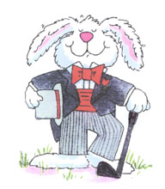

1999 | Chris Taylor
2000 | Mick Cobb
2001 | Colin Bee
2002 | Colin Bee
2003 | Tony Harvey
2004 | Derek Chapman
2005 | Peter Sivill
2006 | Paul Carr
2007 | Mick Mawson
2008 | John Spooner
2009 | Gary Noble
2010 | Nino Vacca
2011 | Rob Page
2012  2013  2014  2015  2016  2017  2018 | Carole Fewings  Ian Piears  Nick Milburn  Steve Smeeth  Andy Murton  Ian Scholefield  Andy Davis

